 Shri Ramdeobaba College of Engineering & Management, Nagpur 13

Department of Electronics Engineering

Instrumentation and control lab (ENP354)

Semester: V Session: 2023-24 Section: A Batch: A2

******************************************************************************************

Name of Student: Harsh Devendra Mishra Roll Number: A-22

Date of performance of Experiment: 30/11/2023 Date of Submission of Experiment file: 7/12/2023

******************************************************************************************

# EXPERIMENT NO. 7

Aim of Experiment: - Measurement of vibration using vibration sensor

Objective of Experiment: - Vibration measurement

Tool used: - Arduino, Bread Board, Sensor, power supply, Connecting wires, Laptop/Computer system

******************************************************************************************************** Applications for industrial vibration monitoring:

All industrial machinery vibrates. The level of vibration is a useful guide to machine condition. Poor balance, misalignment & looseness of the structure will cause the vibration level increase, it is a sure sign that the maintenance is needed.

* Frequency range 10 Hz - 1 kHz, sensitivity relative meet ISO 2954.
* Professional vibration meter supply with vibration sensor & magnetic base, full set.
* Velocity measuring range 200 mm/s.
* Acceleration measuring range 200 m/s .
* RMS & Peak measurement.
* Wide frequency range.
* Data hold button to freeze the desired reading.
* Memory function to record maximum and minimum reading with recall. ➢ Separate vibration probe, easy operation ➢ Super large LCD display.
* Microcomputer circuit, high performance.
* Auto shut off saves battery life.
* Built-in low battery indicator.
* Heavy duty & compact housing case.
* Complete set with the hard carrying case.

Specifications:

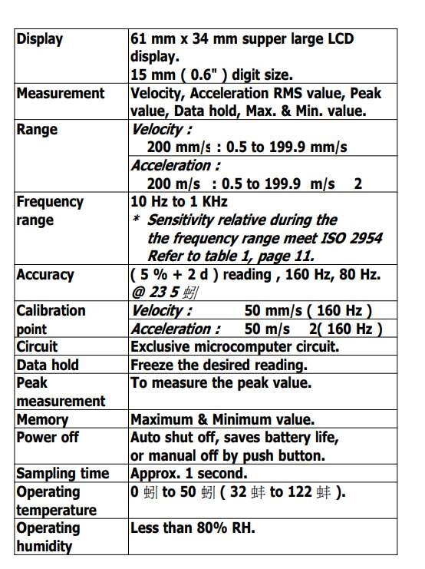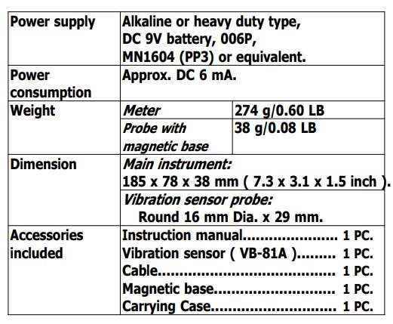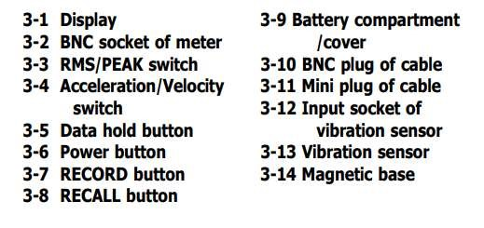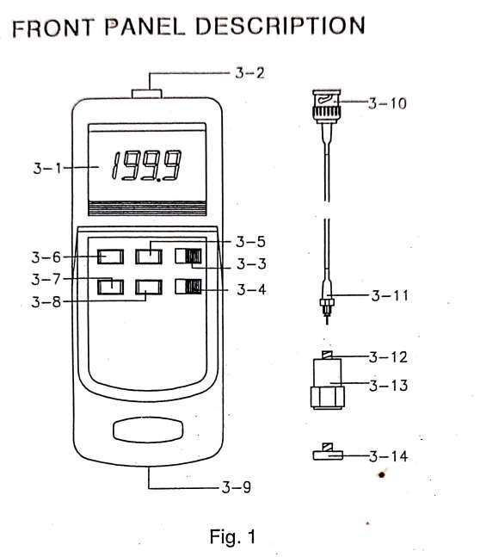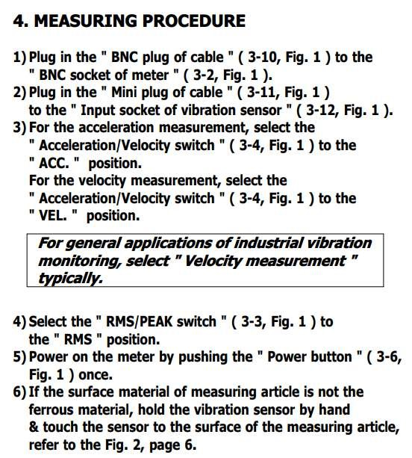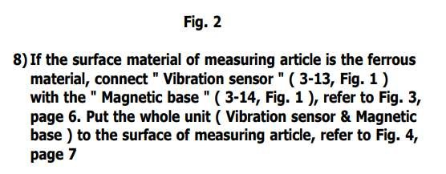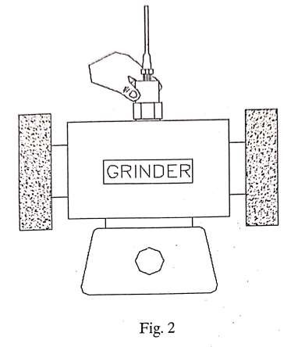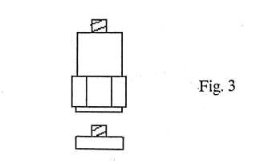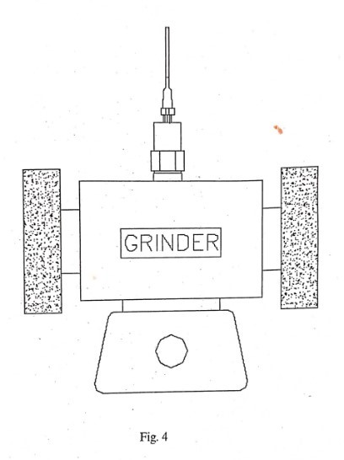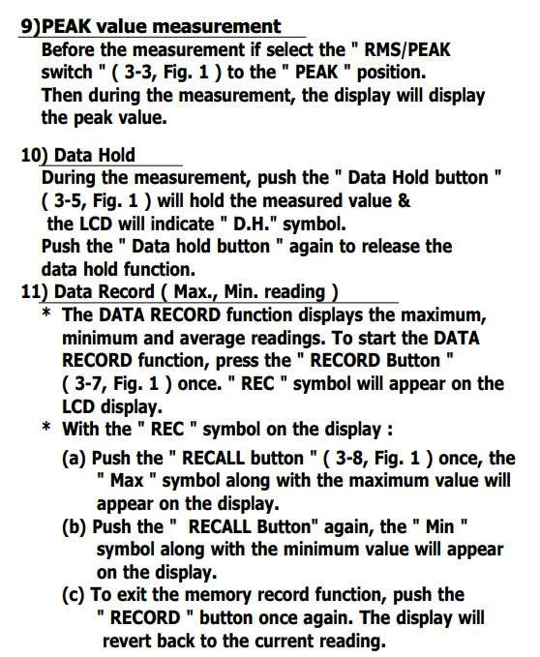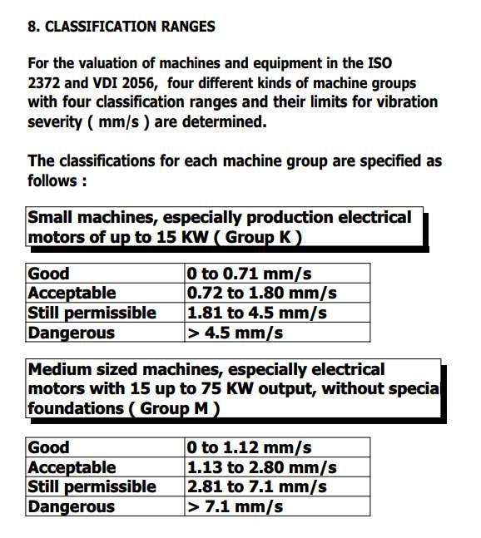

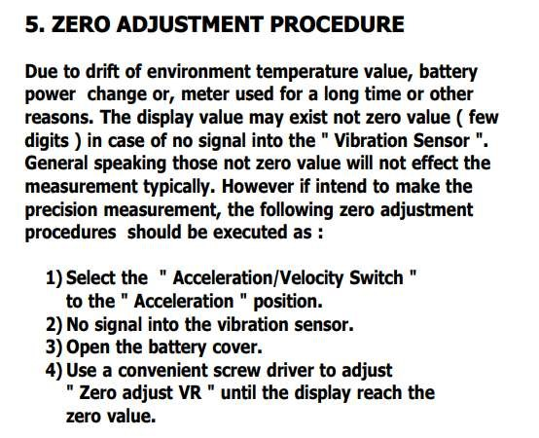

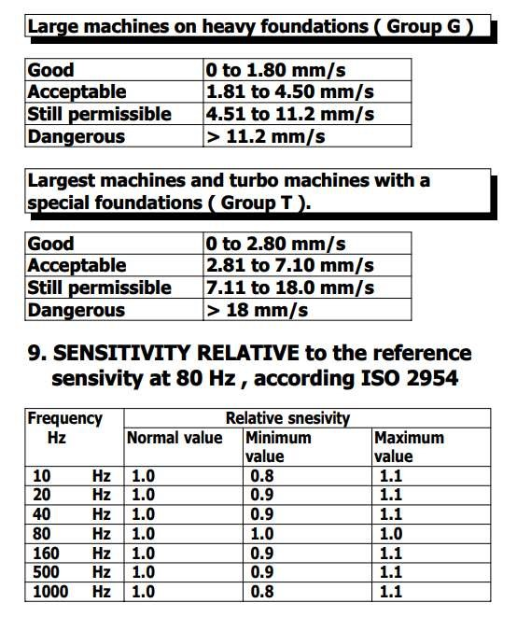

Result: -

Output: -

|  |  |  |
| --- | --- | --- |
| SR.No | Voltage | Vibration (RMS) |
| 1 | 1.2 | 0.3 |
| 2 | 2 | 2.2 |
| 3 | 2.3 | 2.3 |
| 4 | 2.9 | 7.7 |
| 5 | 3.5 | 13.1 |
| 6 | 4 | 20.1 |
| 7 | 5.1 | 26.1 |
| 8. | 6.3 | 33.3 |

Graph -

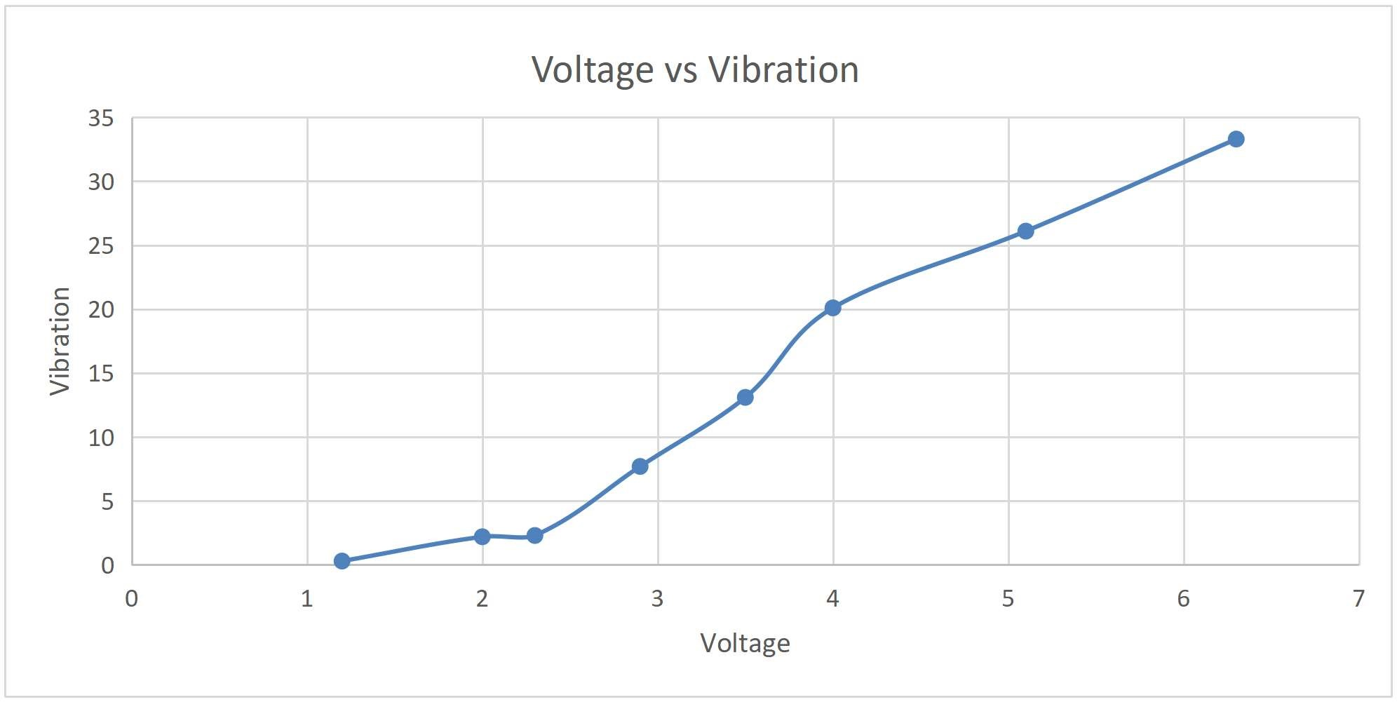

Conclusion (Write Proper Conclusion based on your results & understanding):-

● In conclusion, the experiment focused on the measurement of vibrations using a vibration sensor achieved its primary aim by providing valuable insights into the dynamic characteristics of the tested system. The chosen vibration sensor demonstrated its reliability and sensitivity in accurately quantifying vibrational patterns, including amplitude, frequency, and duration.

● The collected data not only confirmed the sensor's effectiveness in detecting vibrations but also highlighted its potential applications in structural health monitoring and machinery diagnostics. The experiment emphasized the importance of a well-designed experimental setup and calibration to ensure the accuracy of the measurements, taking into account factors such as sensor placement and environmental conditions. Overall, this research lays the foundation for future studies and practical implementations involving the precise measurement and analysis of vibrations for system optimization and failure prevention.